10-3: Multiple-Row Subqueries

1. What will be returned by a query if it has a subquery that returns a null ?

no data found

1. Write a query that returns jazz and pop songs. Write a multi-row subquery and use the d_songs and d_types tables. Include the id, title, duration, and the artist name.

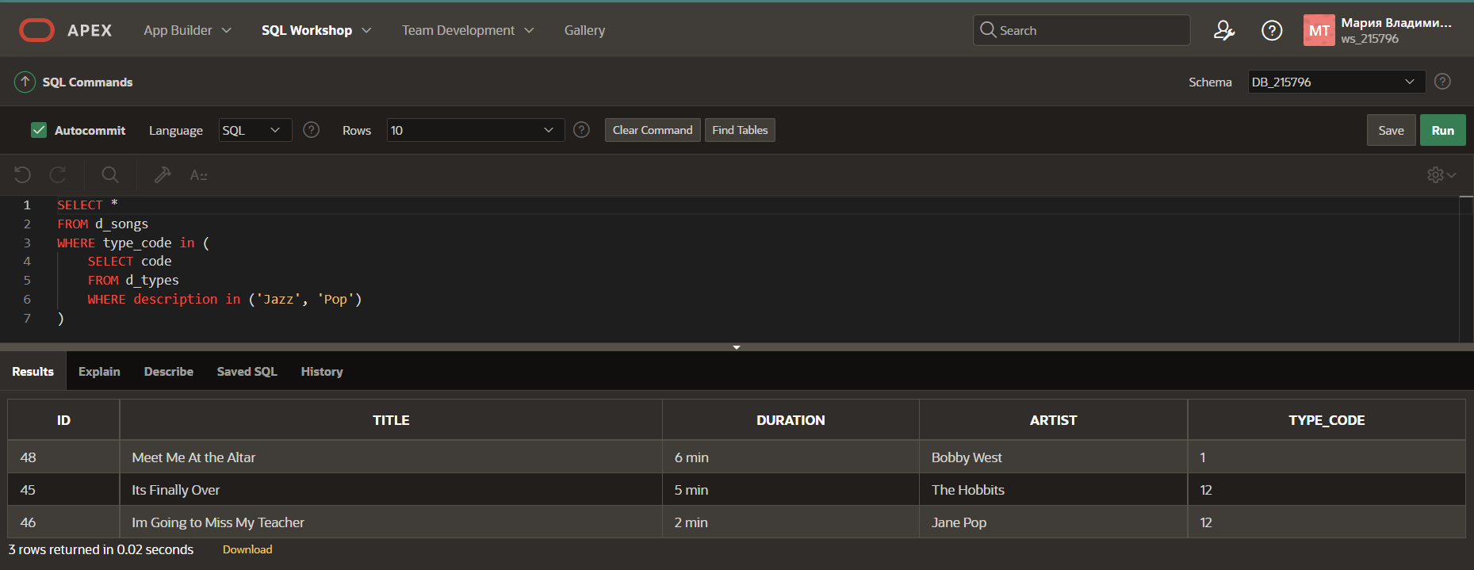

1. Find the last names of all employees whose salaries are the same as the minimum salary for any department.

1. Which Global Fast Foods employee earns the lowest salary? Hint: You can use either a singlerow or a multiple-row subquery.

5. Place the correct multiple-row comparison operators in the outer query WHERE clause of each of

the following:

a. Which CDs in our d_cds collection were produced before “Carpe Diem” was produced?

SELECT title, year

FROM d_cds

WHERE year < (

SELECT year

FROM d_cds

WHERE title = 'Carpe Diem');

b. Which employees have salaries lower than any one of the programmers in the IT department?

SELECT first_name || ' ' || last_name "NAME", salary

FROM employees

WHERE salary < ANY (

SELECT salary

FROM employees

WHERE department_id = (

SELECT department_id

FROM departments

WHERE department_name = 'IT'

)

)

c. What CD titles were produced in the same year as “Party Music for All Occasions” or “Carpe

Diem”?

SELECT title, year

FROM d_cds

WHERE year in (

SELECT year

FROM d_cds

WHERE title in ('Carpe Diem', 'Party Music for All Occasions')

)

d. What song title has a duration longer than every type code 77 title?

SELECT title

FROM d_songs

WHERE duration > ALL (

SELECT duration

FROM d_songs

WHERE type_code = 77

)

6. If each WHERE clause is from the outer query, which of the following are true?

__T__a. WHERE size > ANY -- If the inner query returns sizes ranging from 8 to 12, the value 9

could be returned in the outer query.

__F__b. WHERE book_number IN -- If the inner query returns books numbered 102, 105, 437,

and 225 then 325 could be returned in the outer query.

__F__c. WHERE score <= ALL -- If the inner query returns the scores 89, 98, 65, and 72, then 82

could be returned in the outer query.

__T__d. WHERE color NOT IN -- If the inner query returns red, green, blue, black, and then the

outer query could return white.

__F__e. WHERE game_date = ANY -- If the inner query returns 05-Jun-1997, 10-Dec-2002, and

2-Jan-2004, then the outer query could return 10-Sep-2002.

7. The goal of the following query is to display the minimum salary for each department whose minimum salary is less than the lowest salary of the employees in department 50. However, the subquery does not execute because it has five errors. Find them, correct them, and run the query.

SELECT department_id, MIN(salary)

FROM employees

GROUP BY department_id

HAVING MIN(salary) <

(SELECT MIN(salary)

FROM employees

WHERE department_id = 50);

8. Which statements are true about the subquery below?

SELECT employee_id, last_name

FROM employees

WHERE salary =

(SELECT MIN(salary)

FROM employees

GROUP BY department_id);

___F___ a. The inner query could be eliminated simply by changing the WHERE clause to

WHERE MIN(salary).

___T___ b. The query wants the names of employees who make the same salary as the smallest

salary in any department.

___F___ c. The query first selects the employee ID and last name, and then compares that to the

salaries in every department.

___T___ d. This query will not execute.

9. Write a pair-wise subquery listing the last_name, first_name, department_id, and manager_id for all employees that have the same department_ id and manager_id as employee 141. Exclude employee 141 from the result set.

10.Write a non-pair-wise subquery listing the last_name, first_name, department_id, and manager_id for all employees that have the same department_ id and manager_id as employee 141.

